**Mineral-hosted biofilm communities in the continental deep subsurface, Deep Mine Microbial Observatory, SD, USA**

Caitlin P. Casar1, Brittany R. Kruger3, Theodore M. Flynn2, Andrew L. Masterson1, Magdalena R. Osburn1

1Northwestern University, Department of Earth and Planetary Sciences, Evanston IL, 60208

2Argonne National Laboratory, Argonne IL

3Desert Research Institute, Division of Hydrologic Sciences, Las Vegas NV, 89113

**Abstract**

A vast quantity of prokaryotic life on Earth is present in deep subsurface biofilms (Flemming and Wuertz, 2019); however, the ecology of these communities in terms of diversity and biomass is not well constrained. Samples from marine and terrestrial deep subsurface systems have revealed abundant and diverse microbial life suspended in fluids (i.e. fracture and pore fluids); however, the same is not well described for microbial life attached to surfaces (i.e. biofilms on rock fracture and pore space surfaces). The recently established Deep Mine Microbial Observatory is a long-term monitoring station at which we can explore the role of biofilms in fluid-filled fractures to depths of 4,850 ft. …

**1 | INTRODUCTION**

The continental deep subsurface biosphere theoretically extends to depths in Earth’s crust at which the physicochemical limits of life exist (i.e. temperature, pressure, and presence of water) (Hazael *et al.*, 2016), and has been directly observed as deep as 2.8km (Chivian *et al.*, 2008). Conditions found within deep subsurface environments pose distinct biological challenges; for instance, the lack of direct energy from sunlight, limited organic carbon and oxygen. However, fluid-filled fractures can serve as oases for microbial life. Here, interactions between the host rock and fracture fluids provide abundant insoluble and dissolved electron donors and acceptors, establishing chemical disequilibrium that can support a variety of chemolithotrophic microbial metabolisms. Although the relative importance of chemolithotrophs specifically is unknown, the continental subsurface is estimated to host a massive biosphere comprised of as many as 3 x 1029 cells, or 30% of global prokaryotic biomass (Magnabosco *et al.*, 2018; Flemming & Wuertz, 2019). Further, genomic and metagenomic surveys in continental deep subsurface settings have revealed that this biosphere is highly diverse (i.e. Osburn *et al.*, 2014; Magnabosco *et al.*, 2016; Probst *et al.*, 2018). One significant caveat to these studies is that the majority of cell density estimates and sequence-based diversity measures are obtained from microbial communities filtered from fluids, thus missing a potentially significant contribution from communities attached to surfaces as biofilms. This potential significance is underscored by recent estimates of biofilm biomass in the continental subsurface, totaling as many as 2.4 x 1029 cells, or 80% of all continental deep subsurface biomass (Flemming & Wuertz, 2019).

Biofilm communities inhabiting the continental deep subsurface have been previously investigated using both laboratory-based (Thomas-Keprta *et al.*, 1998) and *in situ* cultivation approaches (Moser *et al.*, 2003; Lehman *et al.*, 2004; Henneberger *et al.*, 2006). These studies were among the first to identify the potential importance of attached communities in the deep biosphere, noting the potential for significant diversity and biomass in biofilm communities. Direct observations of South African biofilms on pristine fracture surfaces and within *in situ* incubation experiments estimated cell densities ranging from 5 x 104 to 3.4 x 106 cells/mm2 (Moser *et al.*, 2003; Wanger *et al.*, 2006). Compared to relatively low cell densities estimated from the contemporaneous fracture fluids, high biofilm cell densities suggested a competitive advantage to cellular attachment to rock surfaces under oligotrophic conditions. Further, geochemical modelling and PLFA profiles in this setting indicated the potential for microbially-mediated metal reduction (Moser *et al.*, 2003). A study comparing native communities in a basalt aquifer revealed significantly greater metabolic richness in suspended vs. rock-attached communities, and *in situ* cultivation experiments using dialysis chambers revealed differences in microbial community compositions (Lehman *et al.*, 2004). Importantly, the findings from these studies opposed the prior prevailing notion that suspended and attached communities should be similar [reference], warranting further studies using next generation sequencing technology and systematic experimental approach to assay differences in biodiversity and community structure between attached and suspended microbial communities, the attached to suspended biomass ratio, and the metabolic relationships between biofilm community members and their attachment surfaces in the continental subsurface.

The recently established Deep Mine Microbial Observatory (DeMMO) in the former Homestake Gold Mine in Lead, South Dakota, USA, is a long-term monitoring station at which the ecology of the deep continental subsurface can be explored. DeMMO offers convenient access to fracture fluids emanating from a variety of continental rock types spanning depths of 800-4,850 ft, making it possible to monitor fluid chemistry and microbial diversity under a variety of conditions over time. DeMMO is a network of six legacy boreholes that intersect fluid-filled fractures where each borehole has been adapted for periodic fluid sampling and instillation of long-term experiments with minimal disturbance to the fracture fluids. Long-term monitoring of fracture fluids here has revealed stable fluid chemistry since Dec2015 and indicated limited disturbance to the system associated with borehole modification (Osburn *et al.* 2019a *submitted*). Genomic and metagenomic surveys of microbial communities captured from fracture fluids indicate the presence of distinct microbial assemblages at each DeMMO site, locally dominated by candidate phyla and unclassified taxa, that appear to be strongly influenced by fluid geochemistry (Osburn 2019b *in prep*, Momper *et al.* 2019 *in prep*). This site presents a unique opportunity for long-term *in situ* cultivation experiments, following methods from previous studies (i.e. Moser *et al.*, 2003; Lehman *et al.*, 2004), to specifically target unanswered questions regarding the ecology of the attached fraction of the deep continental biosphere. A first order question is how different are the taxonomic compositions of fluid and biofilm communities? While previous studies suggest potential major differences are possible (Lehman *et al.*, 2004; Lehman, 2007), it is thus far unclear whether the microbial diversity of DeMMO is being captured by fluid filtering alone. Further, members of biofilm communities have the opportunity to utilize minerals in the surrounding host rock as energy sources, a strategy that was previously found to be thermodynamically favorable at DemMO (Osburn *et al.*, 2014). While this study found good agreement between the composition of the suspended communities and exergonic modeled metabolisms using soluble substrates, the relationships between the biofilm communities and modeled metabolisms using mineral substrates remains unexplored. Finally, mineral selectivity by microbes has been observed (Murr & Berry, 1976; Lawrence *et al.*, 1997), but identifying the specific taxa and amount of biomass a given mineral type supports in continental deep subsurface environments has not been done previously. By differentiating fluid from biofilm community taxonomy and biomass and relating these properties biofilms to specific mineral types, we aim to constrain controls on biodiversity and biomass in the continental deep biosphere. Here, we describe an *in situ* cultivation-based approach to probe the microbial ecology of mineral-hosted biofilms inhabiting fluid-filled fractures at DeMMO.

**2 | MATERIALS AND METHODS**

**2.1 | DeMMO**

DeMMO is located within the former Homestake Gold Mine, Lead, SD, USA situated in an uplifted, deformed region of Paleoproterozoic metasediments and Tertiary igneous intrusions (Caddey *et al.*, 1991). The former mine, now known as the Sanford Underground Research Facility (SURF), is approximately 2.15 miles wide and is currently accessible to a depth of 4,850 feet; however, previous mining operations extended to a depth of 8,100 feet (Figure 1). The mining levels intersect three major formations: Ellison, Homestake, and Poorman. The Ellison Formation is comprised of pelitic phyllite and interbedded quartzite. The Homestake Formation is gold ore-bearing, carbonate-rich iron formation. The upper Poorman Formation is composed primarily of graphitic phyllite locally rich in iron sulfides and large quartz veins overlaying a lower unit of metabasalt (Yates Unit) (Caddey *et al.*, 1991). The shallow levels and those near to the mine workings capture relatively young fluids that are recharged on annual timescales by meteoric water, whereas deeper sites capture fluids from a regional flow system that have estimated residence times on the order of 10,000 years or greater (Murdoch *et al.*, 2012).

Fracture fluids at sites DeMMO1, DeMMO3, and DeMMO6, hereafter referred to as D1, D3, and D6, are geochemically (Table 1) and taxonomically distinct. D1 is located at a depth of 800 feet, and fluids are moderately reducing with high concentrations of dissolved ferrous iron, dominated by candidate phylum *Omnitrophica* and unclassified taxa. D3 is located at a depth of 2,000 feet, with ferrous iron and sulfate-rich suboxic fluids dominated by members of *Betaproteobacteria* and *Nitrospirae*. D6 is located at a depth of 4,850 feet, with reducing, sulfate and methane-rich fluids dominated by members of *Deltaproteobacteria* and *Firmicutes*. All three of these sites are drilled away from the mine workings and likely have significant water residence times.

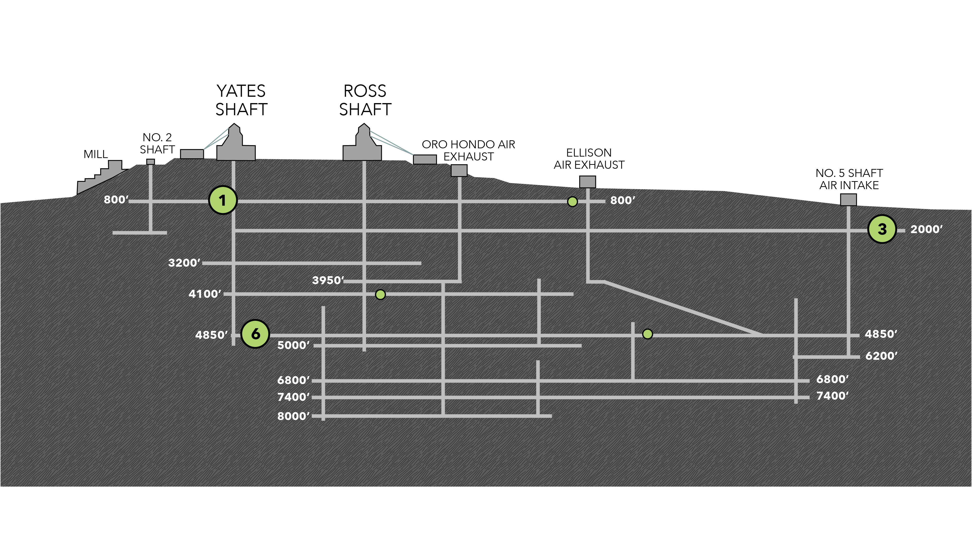**Figure 1.** Cross-sectional view of the Deep Mine Microbial Observatory (DeMMO). Grey lines are tunnels and shafts in the mine. Green circles represent locations of six DeMMO sites, larger circles represent the three sites in this study: D1, D3, and D6.

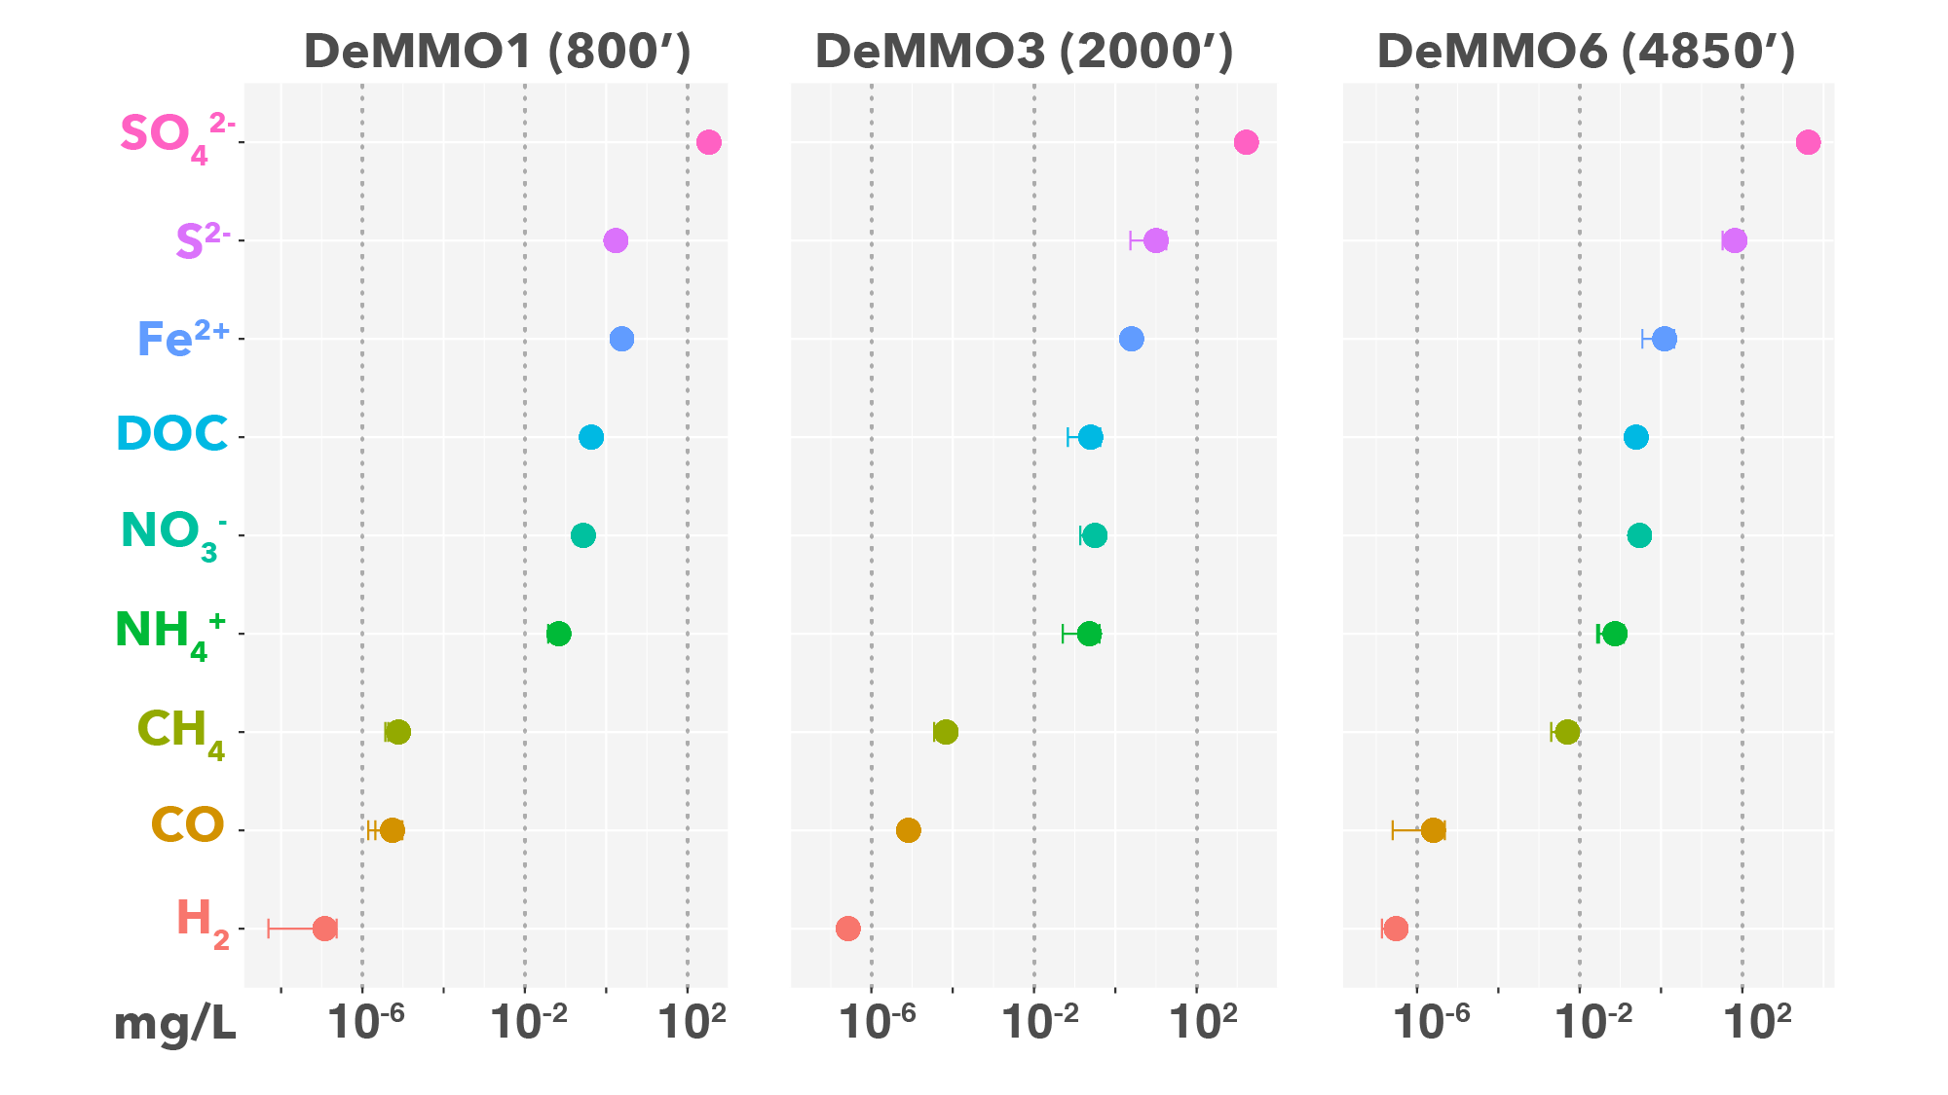**Figure 2.** Averaged fracture fluid chemistry at DeMMO measured between December 2015-April 2018.

**2.2 | Thermodynamic Modeling of Microbial Metabolisms**

To investigate the metabolic potential of biofilm communities, we modeled 39 reactions with minerals under *in situ* conditions at DeMMO (Figure 2). We collected DeMMO fluid geochemical data 11 times between December 2015 and September 2018 (Osburn *et al.*, 2019). This robust geochemical record was used to generate averaged fluid chemistries for D1, D3, and D6 (Table 1) used in species activity calculations via SPECE8 in Geochemist’s Workbench (Bethke *et al.*, 2009). We used DOC concentrations for reactions with acetate. Species activities and average fluid temperatures were used to calculate activity and equilibrium constants for each metabolic reaction in CHNOSZ (Dick, 2008). Finally, Gibbs energy yields (Gr) and energy densities (Er) of each reaction were calculated following the methods of Osburn *et al.*, 2014 (equations 1-3).

**Table 2.** Metabolic reactions with minerals in this study.

|  |  |  |  |  |  |
| --- | --- | --- | --- | --- | --- |
| **No.** | **Reaction** | **e-/rxn** | **No.** | **Reaction** | **e-/rxn** |
| **Pyrolusite as electron acceptor** | | | 23 | CaSO4*2H2O + CH3COO- ↔ HS- + 2HCO3- + Ca2+ + 2H2O | 8 |
| 1 | MnO2 + H2 + 2H+ ↔ Mn2+ + 2H2O | 2 | 24 | CaSO4*2H2O + 8Mn2+ + 10H2O ↔ HS- + 8MnOOH + Ca2+ + 15H+ | 8 |
| 2 | MnO2 + HS- + 2H+ ↔ Mn2+ + S0 + 2H2O | 2 | 25 | CaSO4*2H2O + 4CO + 2H2O ↔ 4HCO3- + HS- + Ca2+ + 3H+ | 8 |
| 3 | 3MnO2 + NH4+ + 4H+ ↔ 3Mn2+ + NO2- + 4H2O | 6 | **Siderite as electron donor** | | |
| 4 | MnO2 + CH4 + 7H+ ↔ 4Mn2+ + HCO3- + 5H2O | 8 | 26 | 2FeCO3 + NO3- +3H2O ↔ 2FeOOH + NO2- + 2HCO3- + 2H+ | 2 |
| 5 | MnO2 + Fe2+ + 2H2O ↔ Mn2+ + 2FeOOH + 2H+ | 2 | 27 | 8FeCO3 + SO42- + 12H2O ↔ 8FeOOH + HS- + 8HCO3- + 7H+ | 8 |
| 6 | 3MnO2 + S0 + 4H+ ↔ 3Mn2+ + SO42- + 2H2O | 6 | 28 | 6FeCO3 + CO + 11H2O ↔ 6FeOOH + 6HCO3- + CH4 + 6H+ | 6 |
| 7 | 9MnO2 + 2CH3COO- + 18H+ ↔ 9Mn2+ + 4HCO3- + 10H2O | 18 | **Hematite as electron acceptor** | | |
| 8 | MnO2 + CO + H+ ↔ Mn2+ + HCO3- | 2 | 29 | Fe2O3 + H2 + 4H+ ↔ 2Fe2+ + 3H2O | 4 |
| **Magnetite as electron acceptor** | | | 30 | Fe2O3 + HS- + 5H+ ↔ 2Fe2+ + S0 + 3H2O | 2 |
| 9 | Fe3O4 + H2 + 6H+ ↔ 3Fe2+ + 4H2O | 2 | 31 | 3 Fe2O3 + NH4+ + 10H+ ↔ 6Fe2+ + NO2- + 7H2O | 6 |
| 10 | Fe3O4 + HS- + 7H+ ↔ 3Fe2+ + S0 + 4H2O | 2 | 32 | 4 Fe2O3 + CH4 + 15H+ ↔ 8Fe2+ + HCO3- + 9H2O | 8 |
| 11 | 3Fe3O4 + NH4+ + 16H+ ↔ 9Fe2+ + NO2- + 10H2O | 6 | 33 | 3 Fe2O3 + S0 + 10H+ ↔ 6Fe2+ + SO42- + 5H2O | 6 |
| 12 | 4Fe3O4 + CH4 + 23H+ ↔ 16Fe2+ + HCO3- + 13H2O | 8 | 34 | 4 Fe2O3 + CH3COO- + 15H+ ↔ 8Fe2+ + 2HCO3- + 8H2O | 8 |
| 13 | 3Fe3O4 + S0 + 16H+ ↔ 9Fe2+ + SO42- + 8H2O | 6 | 35 | Fe2O3 + 2Mn2+ + H2O ↔ 2Fe2+ + 2MnOOH | 2 |
| 14 | 3Fe3O4 + 2CH3COO- + 6H+ ↔ 9Fe2+ + 4HCO3- + 4H2O | 18 | 36 | Fe2O3 + CO + 3H+ ↔ 2Fe2+ + HCO3- + H2O | 2 |
| 15 | Fe3O4 + 2Mn2+ + 2H+ ↔ 3Fe2+ + 2MnOOH | 6 | **Pyrite as electron donor** | | |  |  |
| 16 | Fe3O4 + CO + 5H+ ↔ 3Fe2+ + HCO3- + 2H2O | 2 | 37 | FeS2 + 8NO3- ↔ Fe2+ + 2SO42- + 8NO2- | 16 |
| **Gypsum as electron acceptor** | | | 38 | FeS2+ 2HCO3- + 2H2O + 2H+ ↔ Fe2+ + 2SO42- + 2CH4 | 16 |
| 17 | CaSO4*2H2O + 4H2 + H+ ↔ HS- + Ca2+ + 6H2O | 8 | 39 | 3FeS2 + 8CO + 16H2O ↔ 3Fe2+ + 6SO42- + 8CH4 | 48 |
| 18 | CaSO4*2H2O + 3HS- + 5H+ ↔ S0 + Ca2+ + 6H2O | 8 | * Aqueous forms were used for H2, CO, and CH4  **FeOOH and MnOOH are ferrihydrite and manganite, respectively | | |
| 19 | 3 CaSO4*2H2O + 4NH4+ ↔ 3HS- + 4NO2- + 3Ca2+ + 10H2O + 5H+ | 24 |
| 20 | CaSO4*2H2O + CH4 ↔ HCO3- + HS- + Ca2+ + 3H2O | 8 |
| 21 | CaSO4*2H2O + 8Fe2+ + 10H2O ↔ HS- + 8FeOOH + Ca2+ + 15H+ | 8 |  |  |  |
| 22 | 3CaSO4*2H2O + 4S0 ↔ 4SO42- + 3HS- + 5H+ + 3Ca2+ + 2H2O | 24 |  |  |  |

**2.3 | *In situ* Cultivation Experiments**

We employed *in situ* cultivation experiments to grow biofilm communities on minerals present in DeMMO host rock (Figure 3). An array of flow-through colonization reactors were filled with crushed and polished minerals (pyrite, hematite, magnetite, siderite, pyrolusite, muscovite, gypsum, and calcite), native rock, or inert control substrates (glass beads, glass wool, and sand). Crushed minerals and rocks were mixed with sand to a ratio of ~1:2 to minimize major changes in pH (i.e. in experiments with pyrite where excess pyrite dissolution may result in extremely acidic fluids). The reactors were connected to borehole outflows at DeMMO1, DeMMO3, and DeMMO6 for 2-8 months to allow for colonization by biofilm communities prior to harvesting. After incubation, crushed mineral, rock, or inert control material was collected in sterile tubes and frozen on dry ice in the field for DNA. Additionally, we collected ~1L of fracture fluids on 0.2μm sterivex filters from each site for comparison of DNA from biofilm communities to fracture fluid communities. To control for the mine environment, we extracted DNA from standing water present in mine tunnel ditches and from pre-sterilized glass slides incubated in open air in the mine tunnels for 3 months at depths of 800 and 4,100 feet. Polished mineral and rock coupons or glass slides were included in each experiment for microcopy. Mineral and rock coupons and glass slides were fixed in 4% glutaraldehyde in the field and stored at 4o C (except for gypsum coupons which were not recovered due to dissolution). Raw borehole fluids were also collected for enumeration by epifluorescence microscopy in sterile PET bottles and fixed with 2% paraformaldehyde in the field (Osburn et al., in prep).

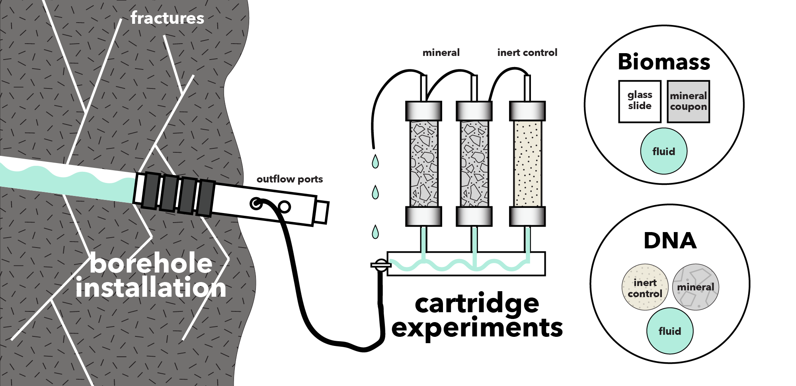

**Figure 3.** Fracture fluids flow from borehole installation sampling ports through cartridges filled with minerals or inert material. Glass slides and mineral coupons were included in the experiments for SEM to estimate biomass. DNA was sampled from fluids and cartridge materials to characterize microbial communities.

**2.4 | Microbial Community Analysis**

We extracted DNA from crushed mineral, rock, inert control, and glass slide ambient background control samples using a MoBIO PowerBiofilm DNA Isolation Kit (Cat. No. 24000-50) and from Sterivex filters using a MoBIO PowerWater Sterivex DNA Isolation Kit (Cat No. 14600-50-NF) following the manufacturer suggested protocol. Whole genomic DNA was sent to Argonne National Laboratory for 16s rRNA amplicon sequencing of the V4 hypervariable region using 516F (GTGYCAGCMGCCGCGGTAA) and 806R (GGACTACNVGGGTWTCTAAT) universal primers. Samples were sequenced on an Illumina Miseq instrument. Paired-end reads were joined with PEAR (Zhang *et al.*, 2014) and demultiplexed with QIIME (v 1.9.1; Caporaso *et al.*, 2010). We acknowledge the growing trend of binning sequences into amplicon sequence variants (ASV’s); however, we characterize microbial communities to the family level and are not attempting to assign strain-level taxonomy to sequences here. Further, alpha and beta diversity metrics were found to be highly correlated when comparing ASV and OTU binning of environmental 16s rRNA gene sequences resulting in ecologically similar interpretations between both approaches (Glassman & Martiny, 2018), thus we chose to bin sequences into operational taxonomic units (OTU’s). Sequences were dereplicated and binned into OTU’s at a threshold similarity of 97%, and chimeric sequences were removed using USEARCH (Edgar, 2013). Rarefied OTU tables were generated in QIIME by randomly sampling sequences between read depths of 0 – 32,500, the approximate median value of total sequence reads among samples, at a step size of 500 and 10 permutations. Rarefaction curves were generated using the averages of the 10 permutations. We chose to normalize our final OTU table for statistical analyses to a depth of 10,000 reads where rarefaction curves began to level off, indicating the read depth sufficiently captured alpha diversity among all samples. Representatives from each OTU were assigned taxonomy using the UCLUST method in QIIME referencing the SILVA132 database (Quast *et al.*, 2012). OTU’s that were classified as “Unassigned” using the SILVA132 database were compared to GDTBK genome taxonomy assignments (Momper et al. in prep). We used an e-value threshold of x to determine quality matches for further taxonomic assignment.

We performed statistical analyses on the rarefied OTU table using QIIME and the Vegan (Oksanen *et al.*, 2019) and Ecodist (Goslee & Urban, 2007) packages in R. Alpha diversity was calculated using QIIME in terms of species richness (number of observed OTUs), evenness (Chao1 and Simpson), and diversity (Simpson, Faith’s, and Shannon). To illustrate beta diversity among DeMMO communities, we visualized DeMMO communities with stacked bar plots illustrating OTU community composition binned at the family level. Families that comprised less than 5% of communities we binned as “Less Abundant Taxa”. To further illustrate beta diversity using our entire dataset of DeMMO communities including all replicates and controls, we performed nonmetric multidimensional scaling (NMDS) with Vegan on communities at the family level using the metaMDS function Bray-Curtis metric with default parameters and a dimension size of 2. We used NCBI BLAST to search for the closest relatives of OTUs of interest (blast.ncbi.nlm.nih.gov).

**2.5 | Microbial Cell Density Estimates**

We documented cell morphologies and estimated cell densities on mineral coupons and inert glass slides included in each experiment from 1,300 scanning electron micrographs. Samples were gradually dehydrated in 200 proof ethanol and subjected to critical point drying to preserve cell structure. Finally, samples were coated with osmium tetroxide to a thickness of 15nm to enhance sample conductivity for imaging on a FEI Quanta 650 environmental scanning electron microscope (SEM) in the EPIC facility at the Northwestern University NUANCE center. Images were collected using an operating voltage of 20 kV, 0.98 torr pressure, and working distance of ~5mm. We collected 20 images from each sample and counted cells from a minimum of either 300 cells or 10 images. In some cases, cells were counted from all 20 images and totaled less than 300 cells. Images were also collected from polished rock (prepared as earlier described); however, we did not estimate cell densities due to rough sample topography. To estimate cell densities, fixed fluids were filtered onto polycarbonate filters, stained with DAPI (4’,6-diamidino-2-phenylindole) for ten minutes, and mounted on glass slides with Citifluor antifade reagent before visualizing with a [insert microscope model here] (Osburn et al. in prep). Fracture fluid cell densities were converted from cells/mL to cells/cm2 by assuming a conservative fracture width of 100μm ((Pagani *et al.*, 2011)).

**3 | RESULTS**

**3.1 Gibb’s free energy and energy density of metabolic reactions with minerals**

We modeled 39 reactions, which range from highly endergonic, +105 kJ/mole e- transferred, to highly exergonic, -89 kJ/mole e- transferred (Figure 3). Of the 23 exergonic reactions, the most exergonic reaction is pyrite oxidation with nitrate, followed all pyrolusite reduction reactions and siderite oxidation with nitrate. All other reactions yielded little to no Gibb’s free energy or were endergonic.

In terms of energy density, carbon monoxide is most energy dense of dissolved reactants. Moderately dense reactants include nitrate, acetate, ferrous iron, methane, and sulfide are moderately dense. Hydrogen is the least dense reactant of the exergonic reactions.



**Figure 3.** Free energy (left) and energy density (right) of reactions with minerals and dissolved electron donors and acceptors based on *in situ* geochemistry.

**3.2 Microbial Communities**

DeMMO fluid and biofilm communities include 7,015 OTU’s (845 families from 66 phyla) after quality filtering and read depth normalization. On average, all communities are highly uneven, fluid communities are more diverse and OTU-rich than their biofilm community counterparts, and mineral-hosted biofilm communities are more diverse than biofilm communities on inert controls (Figure 4).



**Figure 4.** Alpha diversity of DeMMO fluid and biofilm communities.

Microbial communities form distinct groups at each study location in NMDS space ­(Figure 5), where DeMMO1 communities are dominated by members of *Nitrospirae, Omnitrophica, Betaproteobacteria,* and *Chloroflexi*, DeMMO3 by *Beta-, Delta-*, and *Alphaproteobacteria* and *Chloroflexi*, and DeMMO6 communities by *Deltaproteobacteria, Chloroflexi, Acetothermia*, and *Latescibacteria* ­(Figure 6). Likewise, fluid and biofilm communities from each site form distinct groups in NMDS space. Although there are shared taxa among community types, the fluid and mineral-hosted biofilm communities are distinct. Broadly, members of candidate phyla *Omnitrophica* are most enriched in fluid communities, whereas members of *Pseudomondaceae,* *Rhodocyclaceae*, *Thermodesulfovibrionia,* and *Latescribacteria* are most enriched in biofilm communities. Members of *Desulfobulbaceae* and *Thermodesulfovibrionia* are highly enriched in mineral experiments relative to fluid communities, most notably in experiments with pyrolusite. NCBI BLAST results indicate that the *Desulfobulbaceae* in D3 communities on pyrolusite are dominated by an OTU with 92.89% similarity to a strain of *Desulfobulbus propionicus* capable of elemental sulfur disproportionation to sulfide (Pagani *et al.*, 2011). D6 communities are dominated by an OTU with 96.44% similarity to a strictly anaerobic strain of *Desulfobulbus elongatus* isolated from freshwater sediment capable of thiosulfate disproportionation to sulfite (Janssen *et al.*, 1996). The *Thermodesulfovibrionia* in D1 communities on pyrolusite are dominated by an OTU with 83.94% similarity to *Deferrisoma camini*, a thermophilic iron reducer isolated from a marine hydrothermal vent (Slobodkina *et al.*, 2012).

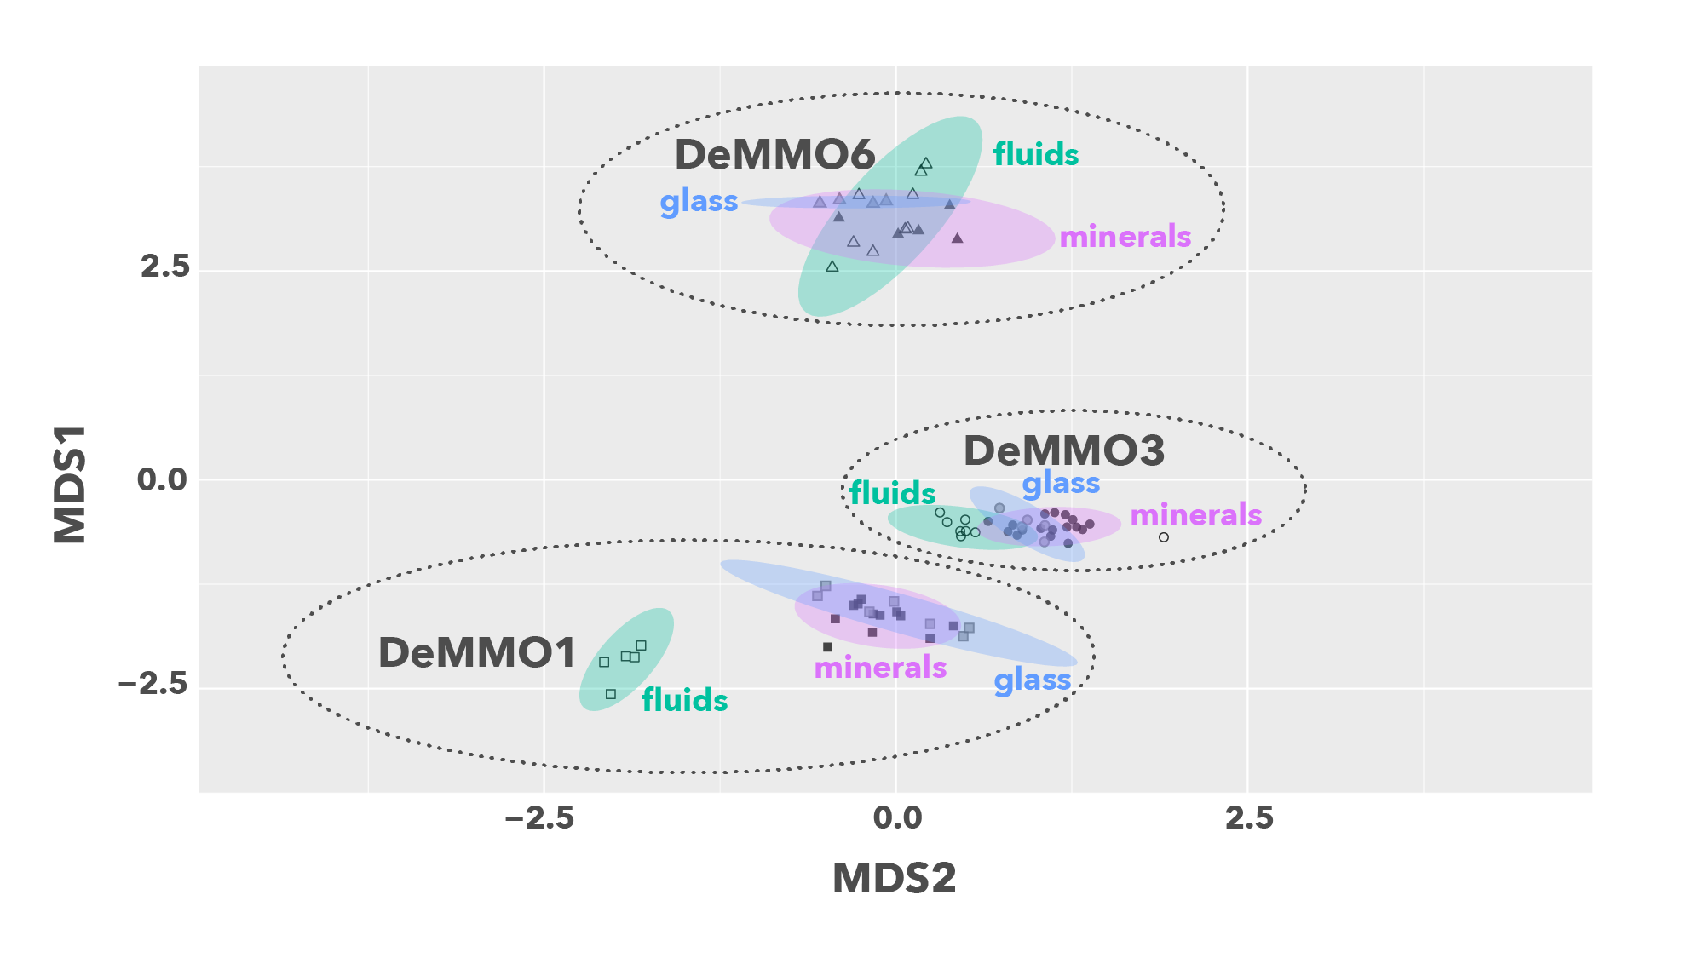

**Figure 5.** NMDS plot of DeMMO fluid and biofilm communities represented as hollow and filled points, respectively. 95% confidence ellipses encompass fluid (green), mineral biofilm (purple) or control biofilm (blue) communities from each site.

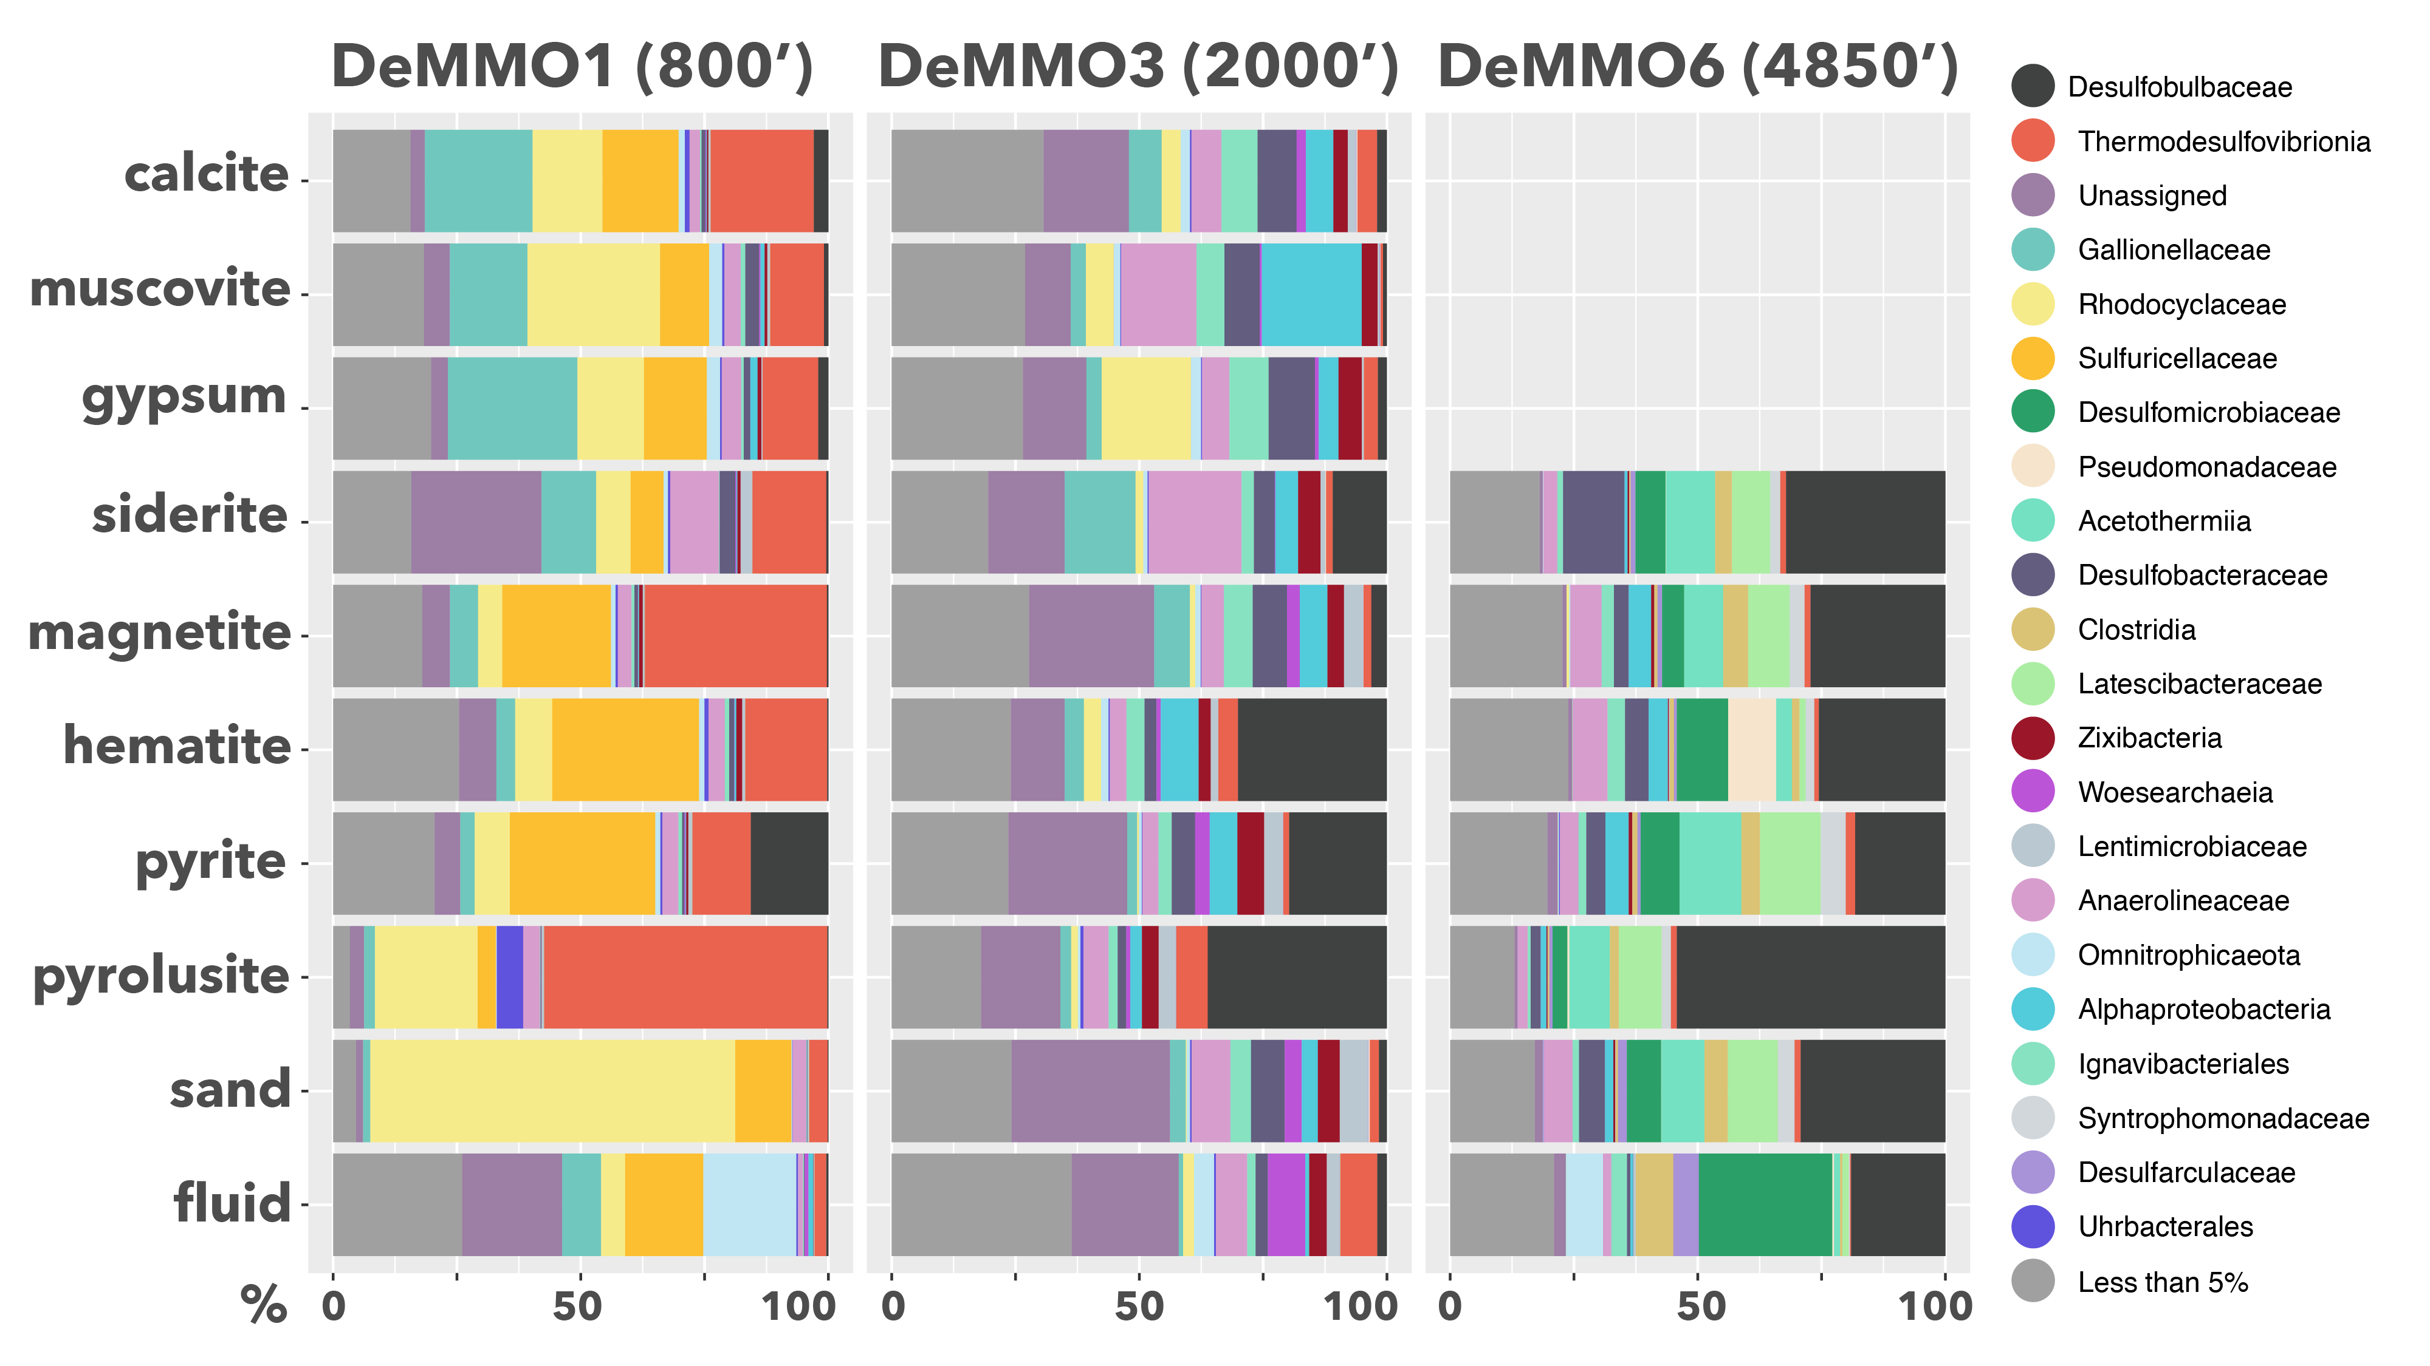

**Figure 6.** Beta diversity of DeMMO communities. Relative abundances of OTU’s binned at the family level from selected DeMMO fluid and biofilm samples. Families that make up less than 5% of a community were binned as ‘Less than 5%”.

* 1. **| Mineral-hosted biomass**

Scanning electron micrographs of biofilms reveal high variation in cell morphologies and densities.

Scanning electron micrographs of biofilms reveal high variation in cell densities and morphologies. Generally, biofilm cell densities are 3-4 orders of magnitude greater than in fluid communities, and cell densities mineral-hosted biofilms are similar or lower than biofilms on inert controls on average (Figure 8). Overall, the highest cell densities were observed in D1 communities, and of these, the highest were in parallel control experiments. Of the minerals, the highest cell densities were observed on pyrolusite, whereas the lowest cell densities were observed on calcite and muscovite. Generally, cell densities were higher on minerals than on internal controls, with exceptions being in D1 communities on pyrite and magnetite.

* + Temporal variability in densities observed at each site, particularly at DeMMO1
  + Cell morphologies differ between minerals and controls

D1:

* Sand – dominated by 0.2μm rods, filaments, and vibrio, local cocci, eps, and gallionella
* Pyrolusite – dominated by rods coccobacillus and filaments, abundant gallionella, local spirillum, cocci, and eps. Internal control looks similar to glass slide in sand experiment – dominated by rods and filaments, local cocci, eps, abundant gallionella
* Magnetite – dominated by rods, local vibrio, filaments, and gallionella. Internal control looks similar to glass slide in sand experiment – dominated by rods and filaments, local cocci, eps, abundant gallionella
* Hematite - Looks similar to glass slide in sand experiment – dominated by rods and filaments, local cocci and gallionella. Internal control looks the same, no gallionella.
* Pyrite – dominated by rods and filaments. Internal control dominate by rods and filaments, local coccobacillus and gallionella.
* Siderite – dominated by rods and filaments, local cocci, vibrio, coccobacillus, gallionella. Internal control looks similar to glass slide in sand experiment – dominated by rods and filaments, local cocci.
* Muscovite – dominated by rods and filaments, local coccobacillus, eps. Internal control dominated by rods, local filaments and coccobacillus.
* Calcite – dominated by 0.2μm rods, local filaments and coccobacillus, local gallionella. Internal control dominated by rods, local cocci and gallionella.

D3:

* Sand – dominated by 0.2μm rods, local 0.2 vibrio and 0.2μm spirochetes.
* Pyrolusite
* Magnetite
* Hematite
* Pyrite
* Siderite
* Muscovite
* Calcite – Dominated by 0.2-0.5μm rods, local 0.5μm cocci. Internal control dominated by 0.2μm vibrio, local 0.2 rods and 0.2 cocci

D6:

* Sand
* Pyrolusite
* Magnetite
* Hematite
* Pyrite
* Siderite
* Muscovite
* Calcite



**Figure 8.** Averaged cell densities estimated from SEM images of glass slides and mineral coupons and filtered fluids. Minerals and fluids are denoted by squares and circles, respectively. Glass slides were included in experiments with minerals (internal inert controls) or sand (parallel inert controls), denoted by stars. Muscovite and calcite experiments were not installed at D6.

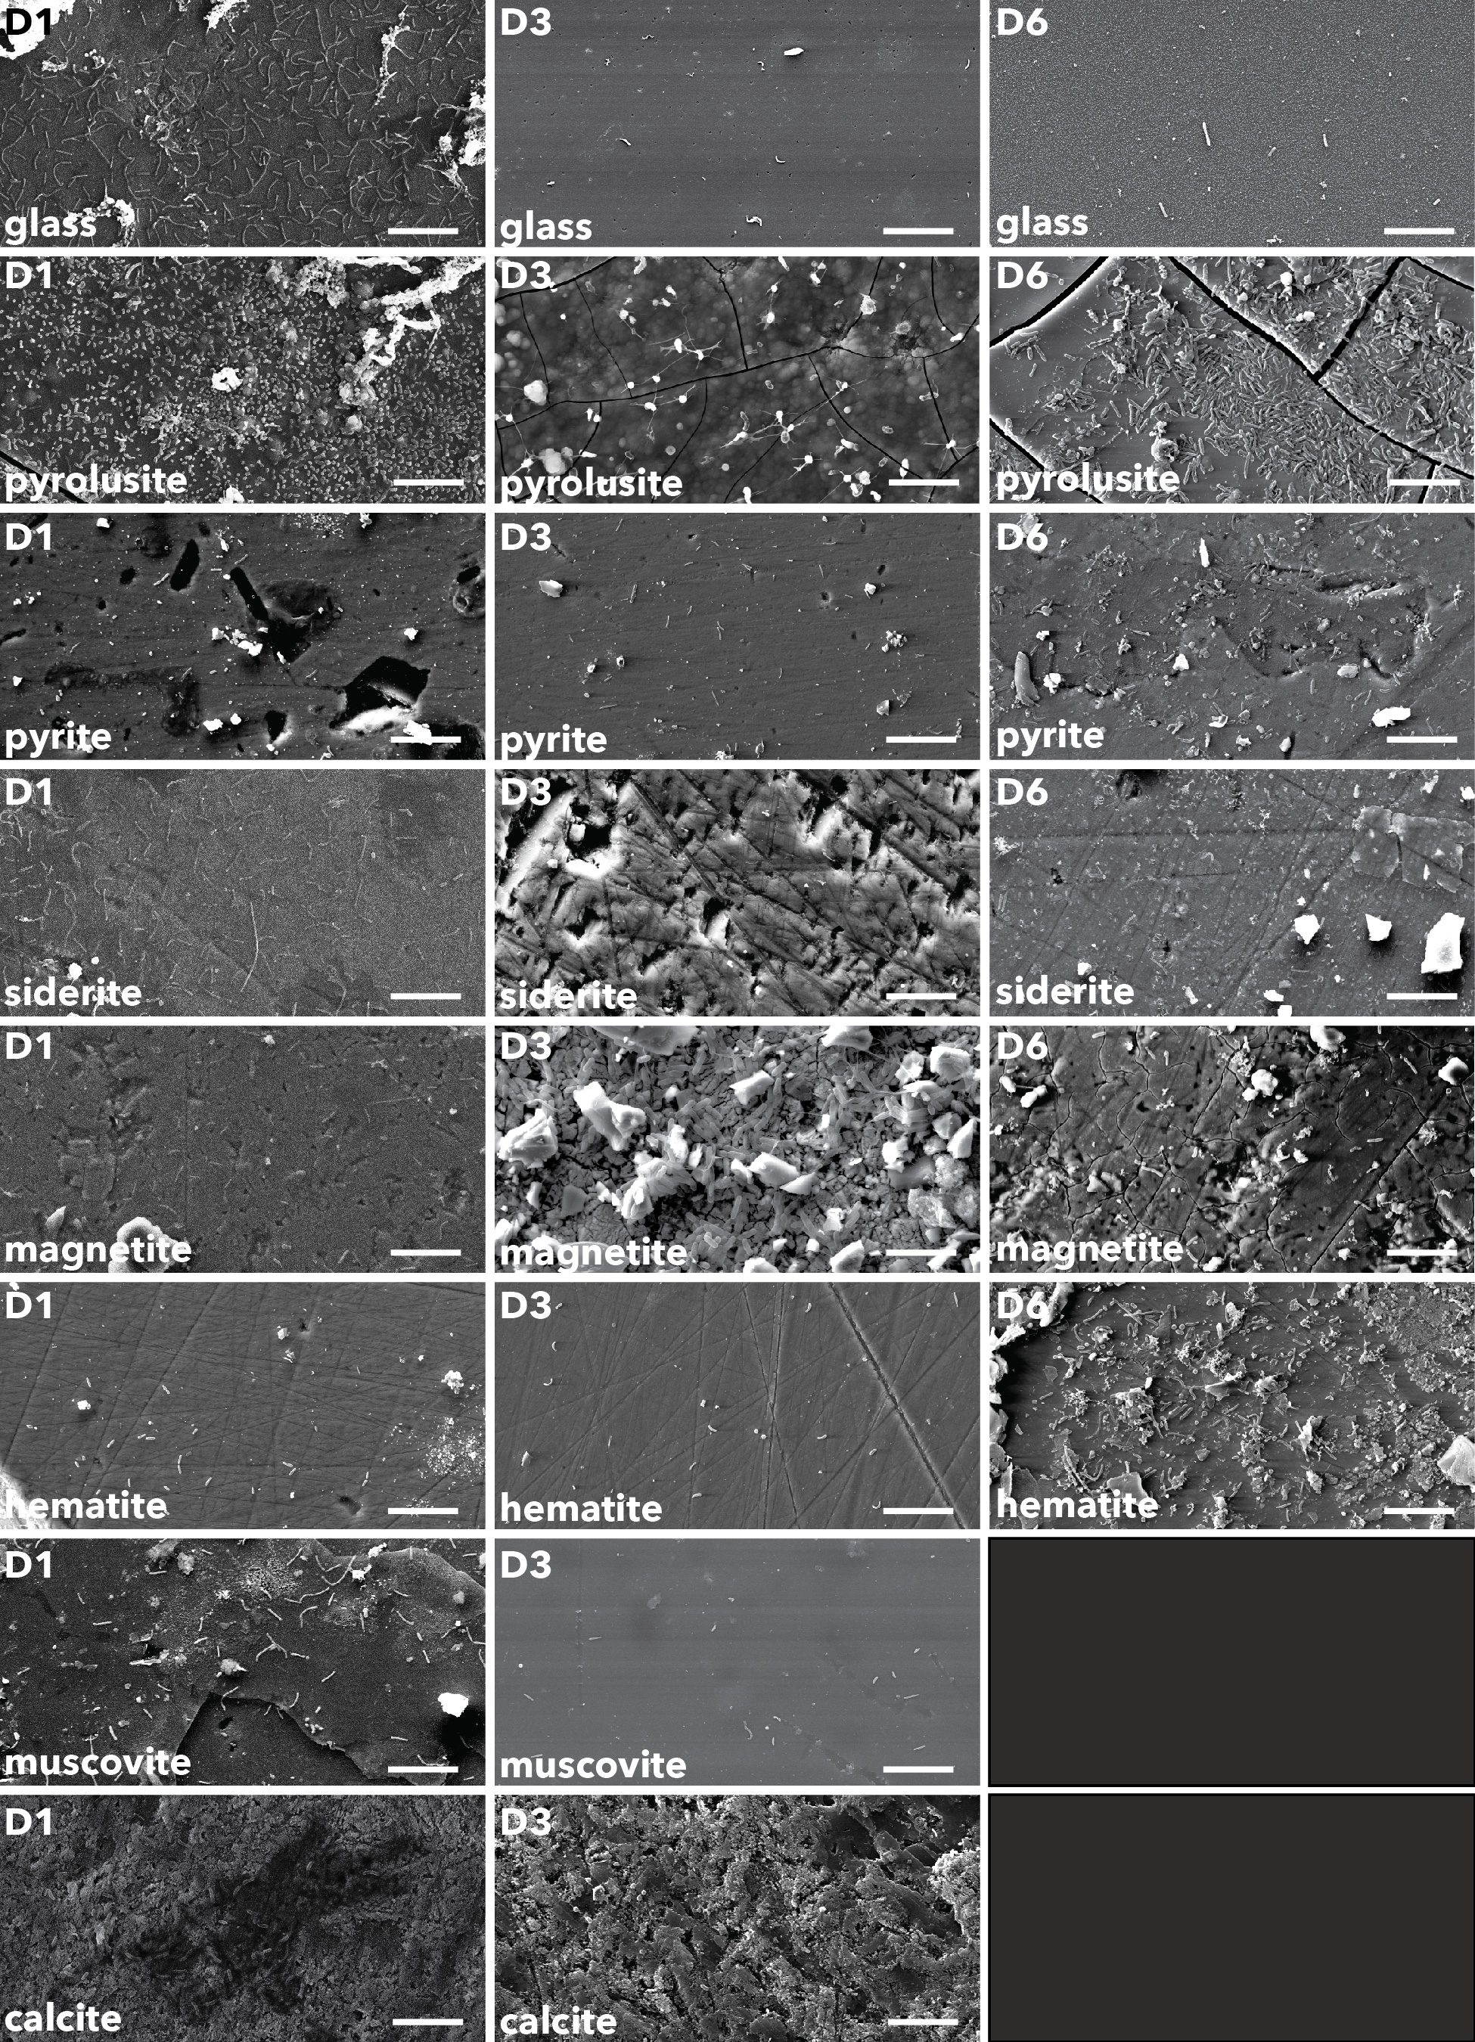

**Figure 9.** Biofilm communities on glass slides and mineral surfaces. Scale bars represent 10μm.

**4 | DISCUSSION**

* 1. **Exergonic mineral metabolisms**

Modeled metabolic reactions reveal that pyrite oxidation with nitrate is the most exergonic metabolism at DeMMO1, 3, and 6; however, energy density calculations where limiting reactants are considered indicate that nitrate is not as available for microbial metabolisms as other dissolved substrates. For example, pyrolusite reduction with carbon monoxide is a highly exergonic reaction and carbon monoxide is abundant, thus this metabolism may actually be move favorable in terms of energy density. Further, cell densities are consistently higher on pyrolusite than on pyrite, further supporting this idea. Given that all reactions with pyrolusite were exergonic at all three DeMMO sites, we expected results from experiments with pyrolusite to be distinct from experiments with other minerals. Indeed, our data suggest pyrolusite may enhance biofilm biomass and promote colonization by specific taxa at DeMMO which we discuss further here.

* 1. **Microbial Communities**

Generally, fluid communities are more taxonomically rich and phylogenetically diverse than their biofilm counterparts, suggesting specialists inhabit biofilm communities. Colonization by specialists may indicate only a subpopulation of the microbiome is capable of biofilm formation or using minerals as sources of energy. Alternatively, competition for dissolved substrates may promote mineral colonization by opportunists capable of taking advantage of energy available in minerals. Diversity has been shown to significantly increase within the first few days of biofilm development and remain relatively stable on timescales similar to our study (Gulmann *et al.*, 2015). We found no clear trends in diversity or biomass with duration of each experiment, which ranged from 80-231 days (Supplementary Figure X), suggesting the maturity of biofilms upon collection.

Our NMDS ordination reveals that fluid geochemistry is the primary driver of dissimilarity among communities between each site (Osburn *et al.*, 2014). DeMMO communities are compositionally distinct from ambient communities in the mine tunnels, indicating DeMMO communities are not influenced by contamination (Supplementary Figure X). While there is a high amount of overlap among fluid and biofilm communities in NMDS space at D3 and D6, D1 fluid and biofilm communities are distinct. D1 communities shift from being dominated by *Omnitrophica* and Unassigned taxa in fluid communities to being dominated *Proteobacteria* and *Nitrospirae* in the biofilms. Several experiments with minerals enriched for biofilm communities distinct from fluid communities or biofilm communities on inert control substrates. Most striking are the experiments with pyrolusite, which enriched for members of the *Desulfobulbaceae* at DeMMO3 and DeMMO6 and *Thermodesulfovibrionia* at DeMMO1, suggesting mineral selectivity by these taxa. The closest relatives of the most dominant OTUs assigned to these taxa were not found to be capable of Mn(II) reduction; however, ferric hydroxide was found to enhance the growth of *Desulfobulbus elongatus* (Janssen *et al.*, 1996). The presence of iron or manganese may indirectly stimulate growth of and promote mineral selectivity by sulfur reducing or disproportionating organisms by scavenging sulfide, a waste product of these metabolisms (Thamdrup, 1993). Alternatively, pyrolusite selectivity may indicate that pyrolusite can be used as an energy source for these taxa. Relatives within the *Desulfobulbaceae* are capable of mineral reduction via extracellular electron transport (EET) (Pfeffer *et al.*, 2012), and we observed distinct wire-like structures on pyrolusite at D3 (Figure 9) that are visually similar to those produced by EET-capable organisms described elsewhere (Reguera *et al.*, 2005).

**4.3 | Mineral-hosted biomass**

Cell densities in biofilm communities are 3-4 orders of magnitude greater than in respective fluid communities, consistent with previous ideas that biofilms likely represent a much greater proportion of biomass in the subsurface than fluid communities (Flemming & Wuertz, 2019). Our estimates for fluid cell densities per square centimeter are conservatively high given our assumptions of a 100μm fracture width, where a width of 4-30μm may be more realistic (Murdoch *et al.*, 2012). However, cell. Further, generally higher cell densities on minerals vs. respective internal controls suggest that minerals enhance biomass. There are several reasons why minerals could promote biofilm formation: charge, energy source, conditioning films enhanced by mineral defects…Minerals rich in iron and manganese promoted higher densities than calcite and muscovite, suggesting potential microbial metal cycling.

**4 | CONCLUSIONS**

We successfully utilized *in situ* cultivation experiments to explore the role of minerals in driving differences in diversity and biomass between fluid and mineral-hosted microbial communities in a continental deep subsurface system. Here, variety of minerals are available as energy sources for microbial metabolisms; however, minerals may only be accessible to specialist taxa. Our findings suggest minerals are selectively colonized by a subset of the microbiome comprised of proportionally greater biomass than the fluid communities. Thus, biofilm formation on mineral surfaces may be a competitive advantage in this system. Taken together, our findings suggest the capacity for a taxonomically distinct mineral-hosted deep subsurface biosphere of significant biomass at DeMMO.

**ACKNOWLEDGEMENTS**

* This work was supported by NASA Headquarters under the NASA Earth and Space Science Fellowship Program – “Grant 80NSSC18K1267” and Exobiology Grant “…” and Northwestern University.
* Undergrads: Bethany Ketchem, Annamarie Jedziniak
* SURF staff: Tom Regan
* This work made use of the EPIC facility of Northwestern University’s NUANCE Center, which has received support from the Soft and Hybrid Nanotechnology Experimental (SHyNE) Resource (NSF ECCS-1542205); the MRSEC program (NSF DMR-1720139) at the Materials Research Center; the International Institute for Nanotechnology (IIN); the Keck Foundation; and the State of Illinois, through the IIN.
* Annette Rowe, Karla Abuyen, Jan Amend, Haley Sapers, Lily Momper

**References**

Bethke, C., & Yeakel, S. (2009). *Geochemist's Workbench: Release 8.0 Reaction Modeling Guide*. RockWare Incorporated.

Flemming, H. C. and Wuertz, S. (2019) *Nat. Rev. Microbio.*, 1.

Jari Oksanen, F. Guillaume Blanchet, Michael Friendly, Roeland Kindt, Pierre Legendre, Dan McGlinn, Peter R. Minchin, R. B. O'Hara, Gavin L. Simpson, Peter Solymos, M. Henry H. Stevens, Eduard Szoecs and Helene Wagner (2019). vegan: Community Ecology Package. R package version 2.5-4. <https://CRAN.R-project.org/package=vegan>

Osburn et al. 2019. Long-term aqueous geochemical stability of the Deep Mine Microbial Observatory (DeMMO), South Dakota USA. Frontiers in Earth Science.

**Supplemental**

* The OTU table and code used to perform statistical analyses and figs can be found at DOI: …, github repo link

**­**

|  |  |  |  |  |  |  |  |  |  |  |  |  |  |  |
| --- | --- | --- | --- | --- | --- | --- | --- | --- | --- | --- | --- | --- | --- | --- |
|  |  |  |  |  |  |  |  |  |  |  |  |  |  |  |
|  |  |  |  |  |  |  |  |  |  |  |  |  |  |  |
|  |  |  |  |  |  |  |  |  |  |  |  |  |  |  |
|  |  |  |  |  |  |  |  |  |  |  |  |  |  |  |



Figure X. NMDS including ambient controls

Figure X. bar plot with dendogram for all communities



**Figure x.** Cell densities vs. duration of each experiment.



**Figure x.** Phylogenetic diversity vs. duration of each experiment.